Postal Life Insurance

Department of Post

Software Requirements Specification (SRS)/ Functional Requirements Specification (FRS)
Missing Requirement Document

INTERNAL APPROVAL FORM

Project Name: Missing Requirement Document
Version: 1.0
Submitted on:
 | Name | Date
Approved By:
Reviewed By:
Prepared By:

VERSION CONTROL LOG
Version | Date | Prepared By | Remarks
1

Table of Contents

1. Executive Summary 4
2. Project Scope 4
3. Business Requirements 4
4. Functional Requirements Specification 5
4.1 Missing Documents Request Page (CPC User Only) 5
4.2 Non-Financial Service Request Indexing page (At Post Office) 6
4.2 Missing Document Upload Page (Link sent to Customer) 7
5. Attachments 7

1. Executive Summary
This document outlines the software requirements for implementing a Missing Requirement Document Management feature for CPC users in India Post PLI. The system will enable CPC users to identify missing documents in customer applications and facilitate communication with customers to either upload the documents online or submit them at the nearest post office.

2. Project Scope
This Module will:
- Allow CPC users to mark missing documents.
- Generate communication (email/SMS/letter) to customers.
- Provide a secure upload link or instructions for physical submission.
- Track document submission status.

3. Business Requirements

ID | Requirements
FS_MRD_001 | CPC users must be able to raise a Missing Requirement request directly from the Insurance Management System, selecting specific documents required from the customer.
FS_MRD_002 | Customers should be able to submit missing documents via secure digital platforms mobile application, customer portal, including self-service (portal upload) and assisted service (at post office counters).
FS_MRD_003 | The system must send real-time alerts to customers via SMS, email, and portal notifications, detailing the missing documents and submission options.
FS_MRD_004 | The system must provide dashboards for CPC users to monitor document submission status
FS_MRD_005 | Uploaded documents must be automatically tagged to the relevant SR, ensuring data integrity and reducing manual intervention.

4. Functional Requirements Specification
Flow Diagram for Missing Requirement Document Process: 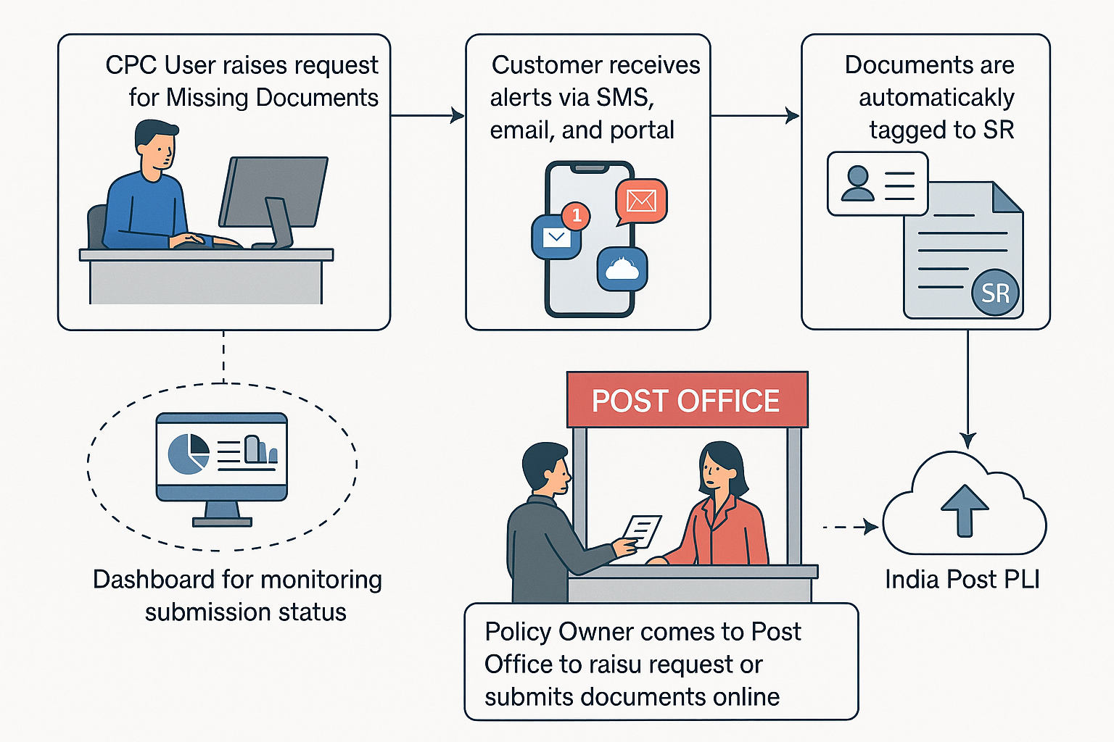

4.1 Missing Documents Request Page (CPC User Only)
- Purpose: CPC User should be able to raise the request for missing documents to be collected from customer. Raising of request by CPC should initiate a link to be sent digitally to customer in their Email, SMS, WhatsApp, etc. in which user can upload the documents, or they can submit the document physically at Post Office.
- Fields:
  - Missing Document Request ID – Auto-generated, read-only unique identifier.
  - Policy Number – Text input, mandatory, validated against active policies.
  - Customer Name – Auto-populated from policy details, read-only.
  - Customer Mobile Number – Auto-populated, editable if needed.
  - Customer Email ID – Auto-populated, editable if needed.
  - Document Type – Dropdown, multi-select (e.g., Identity Proof, Address Proof).
  - Document Description / Remarks – Text area for additional notes.
  - Preferred Submission Mode – Radio buttons (Upload Online / Submit at Post Office).
  - Secure Link Expiry Date – Date picker, default 7 days from request creation.
  - Notification Channels – Checkboxes (SMS, Email, WhatsApp), default all selected.
  - Message Preview – Read-only, shows notification text to be sent.
  - Attach to Service Request (SR) – Auto-tagging enabled upon submission.
  - Dashboard Visibility – Status tracking (Pending / Completed / Expired).
  - Buttons – Submit Request, Cancel, Preview Notification.
  - Previous Request Table with Status: A table should display with previously raised requests along with the status of documents submitted.
- Rules:
  - Successful initiation of request should initiate link to be sent digitally to customer in their Email, SMS, WhatsApp, etc. in which user can upload the documents, or they can submit the document physically at Post Office or through customer portal, mobile application and with help of agent through agent portal.

4.2 Non-Financial Service Request Indexing page (At Post Office)
- Purpose: To create Non-Financial Service Request for Missing Requirements Documents.
- Fields:
  - Missing Document Request ID: Textbox: Input the Missing Document Request ID against which customer is submitting the documents.
  - Request Type: Option should include service request type like Missing Requirement Document, etc.
  - Document Name: Textbox
  - Service Request Date: Calendar: Date on which service request is indexed.
  - Policy Number: Text
  - Office Code: Text: Facility ID of the office where request is getting indexed
  - Service Request Channel: Text: Channel for the service request like RICT, CP etc.
  - Username: Text: Emp ID of the user indexing the request
- Rules:
  - Upon Successful submission, the Missing Documents Request created by CPC user should get updated along with the scanned copy of submitted document.
  - CPC User should be able to Approve or Reject the Document. If the Documents are rejected, link for uploading document will be shared again to the customer.

4.2 Missing Document Upload Page (Link sent to Customer)
- Purpose: To Upload the Missing Document from the auto link sent to customer when the Missing Requirement Document request raised by CPC.
- Field:
  - Policy Number – Displayed, read-only (auto-populated from link).
  - Customer Name – Displayed, read-only (auto-populated).
  - Service Request ID – Displayed, read-only (auto-tagged to SR).
  - List of Required Documents – Dynamic list showing document types requested (e.g., Identity Proof, Address Proof).
  - Upload Document – File upload control for each required document.
    - Features:
      - Accept formats: PDF, JPEG, PNG
      - Max size: e.g., 5 MB per file
      - Drag-and-drop or browse option
  - Remarks (Optional) – Text area for customer notes.
  - Submit Button – To upload and confirm submission.
  - Cancel Button – To exit without uploading.
  - Progress Indicator – Shows upload status (e.g., percentage completed).
  - Help/Instructions Section – Guidelines for acceptable file formats and size.
  - Confirmation Message – Displayed after successful upload with reference number.

5. Attachments
The following documents can be referred.

